Insights on Consumer Behavior in E-Commerce Cosmetic Store

Trilok Dhanekula and Deekshita Chithajhallu – MSBA – BDA 620

Contents
1. Introduction 3
2. Literature Review 3
3. Data Preparation 3
3.1 Data Gathering 3
3.2 Clean and Preprocess the Data 4
3.3 Reduce Data Dimension 4
3.4 Data Mining Task and Importance 5
3.5 Partition of dataset 5
4. Methodology 6
5. Empirical Results 7
6. Conclusions and Recommendations: 8
7. References 9

Introduction

This project embarks on an analytical journey through the e-commerce landscape of the cosmetics industry, focusing on understanding the factors that influence a customer's decision to add a product to their cart after viewing it. The online cosmetics market, rich in diversity and rapidly evolving consumer trends, presents a unique challenge in deciphering customer behavior and preferences. By leveraging data mining techniques on a comprehensive dataset, this study aims to uncover the intricate dynamics between product attributes, customer interactions, and the digital shopping environment. The goal is to gain insights into the conversion process, enhancing the understanding of consumer behavior in e-commerce and contributing to more effective business strategies in the competitive world of online cosmetics retail.

Literature Review

The literature review for this study delves into various domains relevant to our research question. It encompasses studies on consumer behavior in e-commerce, emphasizing the psychological and experiential factors that influence online shopping decisions. Research in data mining and analytics forms a significant part of the literature, highlighting how these techniques can predict and analyze customer purchasing patterns, especially in the cosmetics industry. The review also covers the impact of brand perception and pricing strategies on consumer behavior, acknowledging the critical role they play in a customer's decision to add a product to their cart. Additionally, it touches on the evolving consumer trends in cosmetics, including the rise of organic and influencer-driven products, and the incorporation of advanced technologies like AI and AR in enhancing the e-commerce experience. This study seeks to synthesize these insights, employing data mining to analyze customer behavior from viewing to cart addition, and thus contributing a nuanced understanding of this key stage in the online shopping journey.

Data Preparation

Data Gathering (- refer appendix)
For this study, the data was taken from an online e-commerce cosmetic store from October 2019 which provide a very detail and comprehensive consumer overview. It encompasses a wide range of user actions, providing insights into various parts of customer behavior in e-commerce. Figure below shows the main features of the dataset which shows features like event time, event type, product id and so on.
- 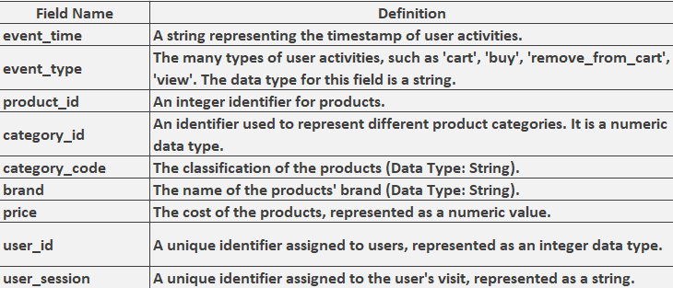

Clean and Preprocess the Data (-refer appendix)
- Before initial analysis, the dataset was clean from any irregularities and missing values. In the dataset feature category code and brand had missing values. Missing category code values were filled in with the label "Unknown," whereas missing brand values were classed as '0' for unknown brands and '1' for known brands. The management of missing values reduces the complexity of the data, making it easier to analyze.
- Moreover, Data transformation technique was also applied on the price column to remove all negative values as price can’t be in negative. For this, the price column was normalized by replacing all those values with the mean price.
- Frequency Distribution of different features like event type, brand and category code were visualized using different bar charts to overall understand the trends and patterns of different users.

Reduce Data Dimension (-refer appendix)
- Data dimension play a vital role when training the model as higher dimension can not only increase the overall computational complexity but also can cause overfitting. Removal of irrelevant features not only will help in increasing the training computational speed as well as also reduce the complexity and noise in the data enabling model to easily understand the important information regarding particular aspects of the data
- Due to this reason for this analysis we reduced less critical variables such as products category codes that provide zero impact on the analysis. These products categories were merge into border categories like appliances, furniture etc. to reduce complexity.
- Moreover, brand was also categorized into simple two labels 1 (Known Labels) and 0 (Unknown Labels) which greatly reduce the dimensionality and streamline our analysis process.
- Another excellent technique for minimizing data is outlier detection and elimination. For this research, the IQR approach was applied to the price feature to identify all outliers in the dataset and removed from the dataset.

Data Mining Task and Importance
The main objective of our data mining task is as followed:
- Prediction of likelihood of the product (`event type cart’) being added in the cart by the consumer or not using machine learning models. This will not only help in understanding user purchase patterns but also help in strategizing targeted marketed product which are similar to the products the model predicts.
- Comparison of two different machine learning model using different evaluation metrics to evaluate which technique perform better in predicting the likelihood of the product being added in the cart.

Partition of dataset (-refer appendix)
Splitting of data is an important phase as it helps in evaluating the performance of the model. In this step, the dataset is split between training and test dataset, where training set is used for training and test set for evaluating the performance of the model. For our analysis, we split dataset where 60% dataset was used for training purpose and 40% dataset was used for testing the model performance. The partitioning ensures that both the training and test sets represent the entire dataset. Furthermore, because our data was imbalanced and leaving it that way could lead to overfitting, we used the ROSE approach on split datasets to synthetically construct data that was as close to the original as feasible.

Methodology (-refer appendix)
For this analysis, following machine learning model were used to predict the likelihood of the product (`event type cart’) being added in the cart by the consumer which are as followed:
Logistic Regression
- Logistic regression is one of the most common machines learning statistical model which is used for predicting binary classification problem. Since, it is a statistical model its output is always in probabilities which in context of e-commerce is valuable as its more easily to determine the overall probability of the likelihood of adding items to a shopping cart and making marketing decision on it.
- Dependent variable: For this analysis our dependent variable is `event_type_cart` which is a binary feature consisting of two outcomes product being added in cart (1) and product not being added (0).
- Independent variable: Different independent variables are used for training which include time-based variables, categorical variables like category code, brand and continuous variables like price.
- Expected Coefficient sign: Coefficient is either positive or negative. For logistic regression positive coefficient will indicate that there is high likelihood that user will add this item in the cart where as negative coefficient will indicate that likelihood of add that product in cart decrease significantly.
Decision Tree
- Decision tree is another really important advance machine learning model which work uses tree-like structure for making prediction. Decision tree are really good model in easily capturing non-linear relationship between variable which in context of our problem could easily help in capturing non-linear relationship between different variables in consumer data.
- Dependent Variable: Similar to Logistic regression, it will also predict `event_type_cart`.
- Independent Variable: Again, similar to logistic regression, all independent variable be same as it makes comparing both models easily.
- Expected Sign Coefficients: Decision tree do not provide Coefficients as it’s has a tree-based structure and it can easily handle both numerical and categorical features easily.

Empirical Results
Following steps were applied for training the machine learning models which are as followed:
- The data was first cleaned which included handling missing value, normalizing and transformation of variables.
- Dimensionality of the data was reduced by removing irrelevant categories, brand and removal of outliers.
- Data was split between into training and testing phase as well as balanced so that it can then trained on the logistic regression and decision which optimized parameters to get overall best accuracy.
Challenges
- One of the main challenges that occur when training the model is the handling of imbalanced dataset as our target variable `event_type_cart’ was highly imbalanced which label `0` instance. This high imbalanced data can easily lead to the biasness of the model for `0` instance which will eventually lead to overfitting. To handle this issue, ROSE was implemented which is synthetic oversampling technique which balanced the dataset.
- The dataset before data cleaning had high number of variables and their distinct rows, the removal of these irrelevant categorical codes helps in reducing the dimensionality.
- Another challenge that needed to be handle was skewness of features like price which were rightly skewed so much due to having outliers. IQR technique was used to removal all outliers.
Iterative Process and Model Refinement
- For training the logistic regression we used `glm` method using cross validation (cv=5) which is an iterative method of splitting the dataset into 5 subset and then iteratively train the model one by one while the other taken as validation method. This approach not only keep model from overfitting but also provide a robust method of evaluation model performance which eventually help in improving model performance.
- Subsequently, Decision tree is also using cross validation iterative method with `rpart` model that train the decision tree model. he Decision tree iteratively focuses on capturing non-linear correlations between variables while handling overfitting using cross validation.

Conclusions and Recommendations: (-refer appendix)
- Table below shows the overall model compression between logistic regression and decision tree. From the table we see that decision tree performed better then logistic regression with an overall accuracy, Sensitivity and Error rate of 62%, 74% and 38% respectively though with a lower specificity of only 34% indicates that decision tree has far more tendency to give false positive then logistic regression which is more overall balance in making fewer false positive as shown below. Furthermore, as shown in table , additional analysis was performed utilizing the Lift Curve. The Lift curve indicates how well the model predicts positive cases; a high number indicates that the model predicts well, and vice versa. Both logistic regression and decision tree have a good Lift index, with logistic regression having a value of 106 and decision tree having a value of 110, indicating that choice tree was slightly more effective at predicting the top 10% of cases.
Metric | Logistic Regression | Decision Tree
Accuracy | 52.51% | 62.02%
Sensitivity | 49.44% | 74.72%
Specificity | 59.10% | 34.75%
Error Rate | 47.49% | 37.98%
Lift at Top Decile | 106 | 110

Interpretation from a Marketing Analytics Perspective:
Model Selection
- Decision tree was more accurate then logistic regression is more useful and suitable for marketing strategies where we need to predict many potential buyers of the product, while logistic regression is more suitable when resources are limited and precision is needed as logistic regression predict less false positive the decision tree
Marketing Strategies:
- In term of marketing strategies, both models have their specific pros and cons. For decision tree it should be used for broad reaching campaigns whose sole aim is to increase the potential customer segmentation, while for logistic regression it should be used where we have a targeted marketing camping where we need as much as less false positive as they can lead to only increasing the cost of the marketing strategy.
Recommendations
- In Future, the model performance can be furthered improved a lot using more different type of machine learning model like random forest which is an ensemble model and provide a better balance between specificity and sensitivity..
- More advance feature engineering techniques cane be implemented to extract more better features that can help in improving model performance such as feature importance, time-based features, customer segmentation, Dimensionality reduction etc.

References

2023 Ryder E-Commerce Consumer Study. (2023, September 19). Ryder Website. https://www.ryder.com/en-us/insights/white-papers/e-commerce/2023/9/19/2023-ryder-e-commerce-consumer-study
- 2023 Online Consumer Behavior Global Report. (n.d.). Digital Commerce 360. https://www.digitalcommerce360.com/industry-resource/2023-online-consumer-behavior-global-report/
- Quigley, J. (n.d.). CONSUMER BEHAVIOR IN DIGITAL MARKETS. https://opensiuc.lib.siu.edu/cgi/viewcontent.cgi?referer=&httpsredir=1&article=1777&context=gs_rp
- The Power of Data-Driven Marketing. (n.d.). Www.spinutech.com. https://www.spinutech.com/digital-marketing/analytics/analysis/the-power-of-data-driven-marketing/
- Akter, S., & Wamba, S. F. (2016). Big Data Analytics in E-commerce: a Systematic Review and Agenda for Future Research. Electronic Markets, 26(2), 173–194. Springer. https://doi.org/10.1007/s12525-016-0219-0

Appendix :
Top 10 Brands
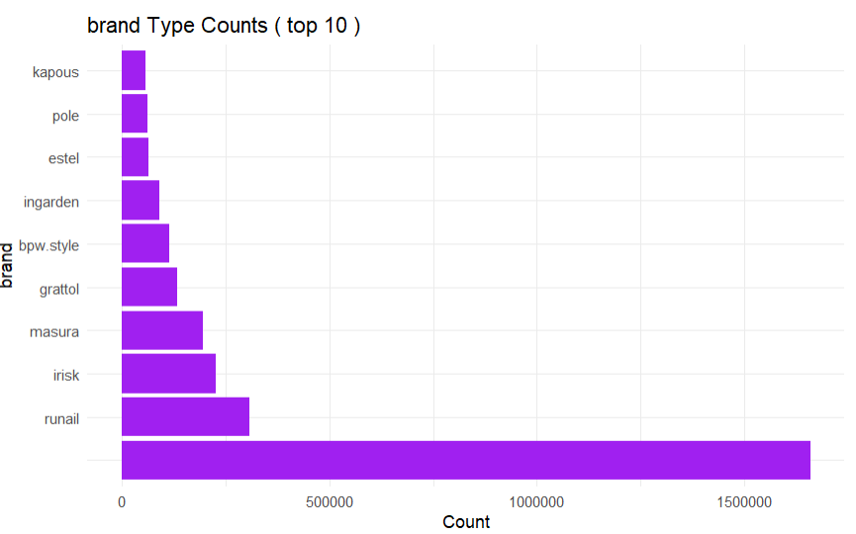

Category Code Counts
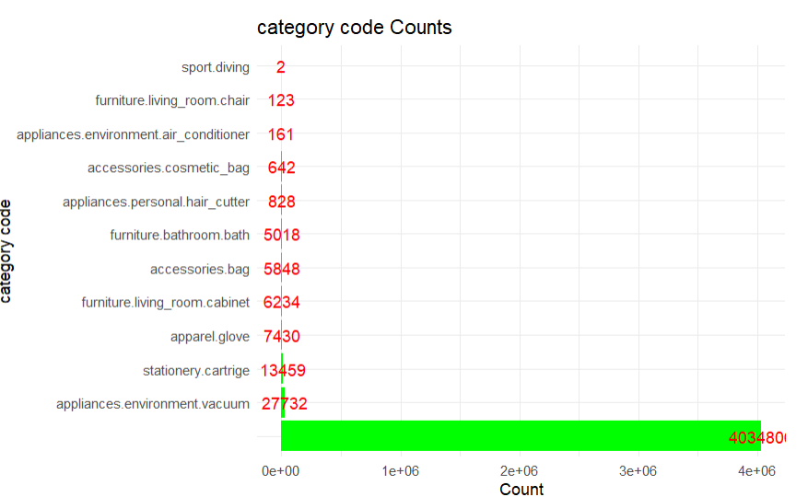

Category Type
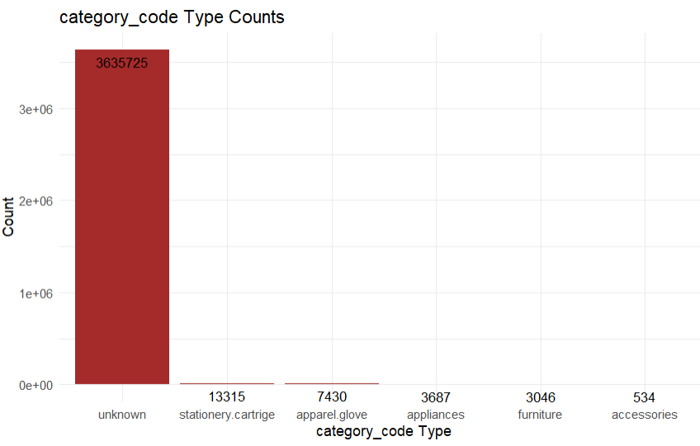

Brand Type
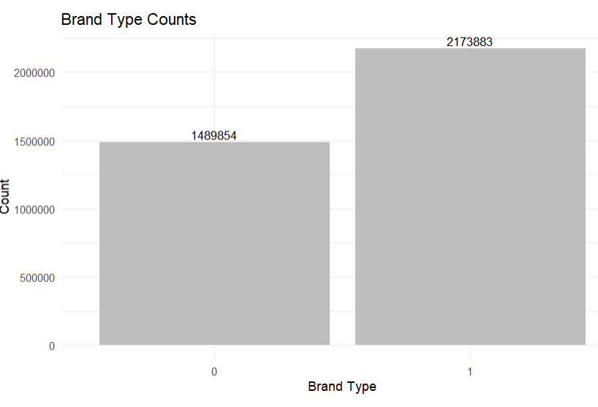

Price Distribution

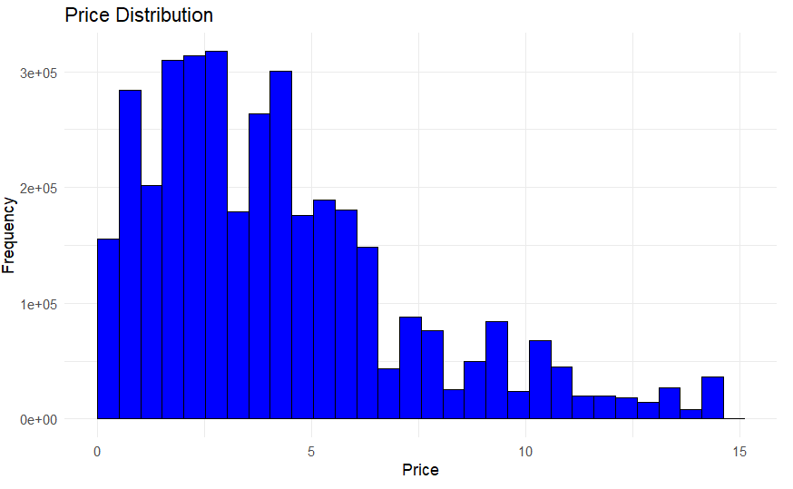

Data Partition
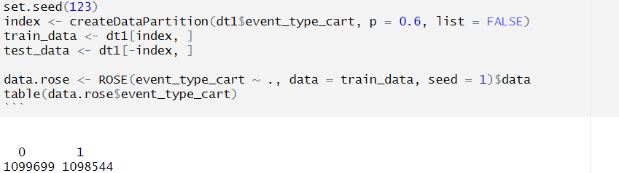

Models and Confusion Matrix
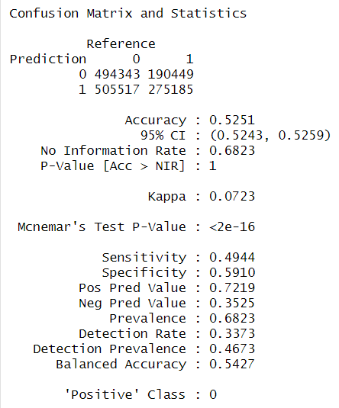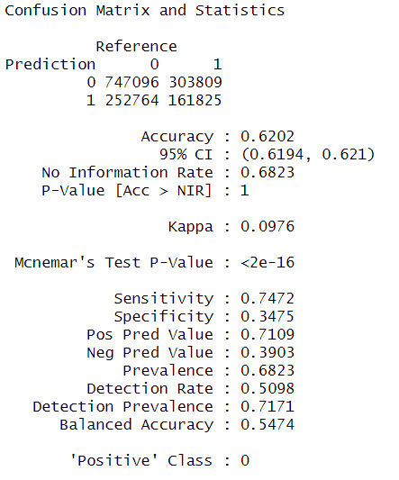

- Event Type Counts: Event Type Count showing the frequency of the different type of customer interaction with the cosmetic products showing how many customer views the product, add it to car, remove them from cart or purchased those products.
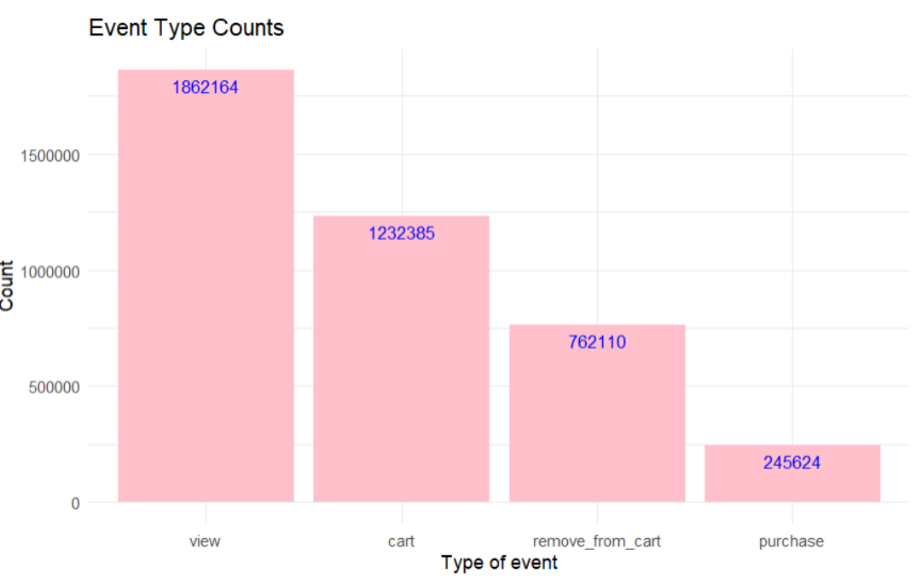
- Brand Type Counts: Shows the bar chart of different brand types, showing which brands are most popular among them customers. Moreover, the graph follows a long-tail distribution, indicating that there are specific few brands in the dataset that have relatively high number of interaction then others.
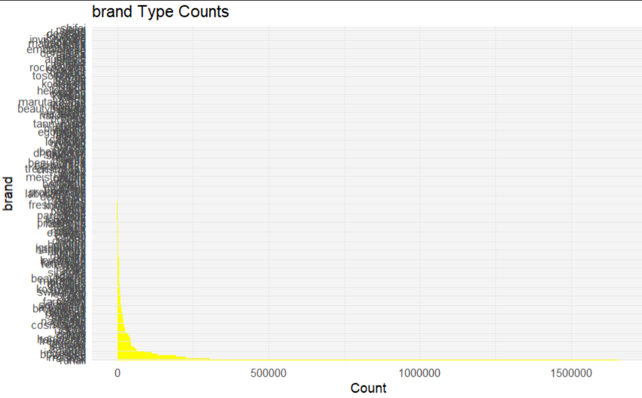

- Price Distribution: Histogram was created to understand the overall distribution of price in our dataset. The chart showed that the price is rightly skewed and majority of the prices are in lower price range indicating that the e-commerce cosmetic site has relatively affordable options in the inventory. the lower price range, indicating a concentration of affordable options within the inventory.
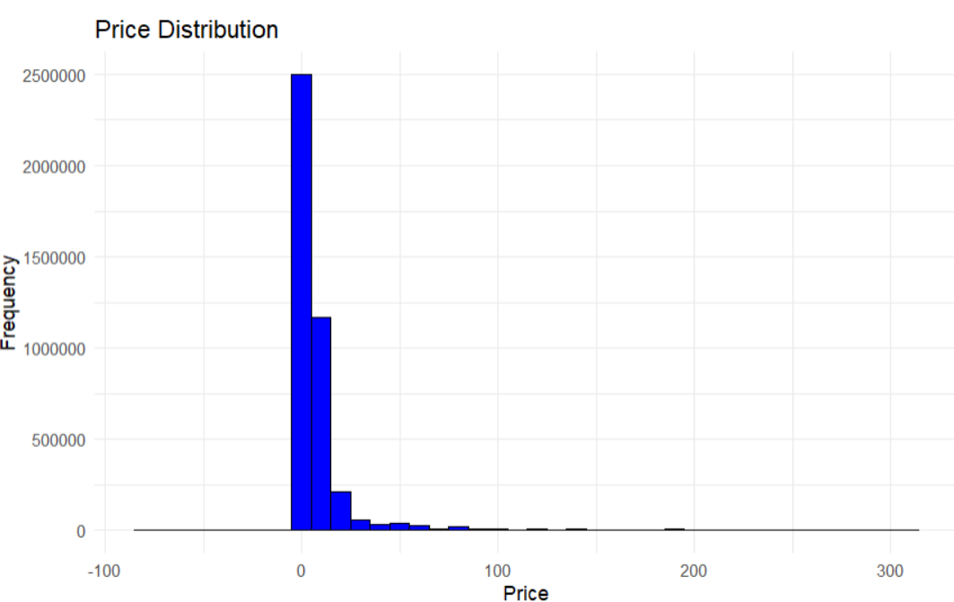
- Event Type Counts after outlier removal: Similar to first chart shows the count of frequency of customers interacting with the website after the removal of specific outliers from the dataset.
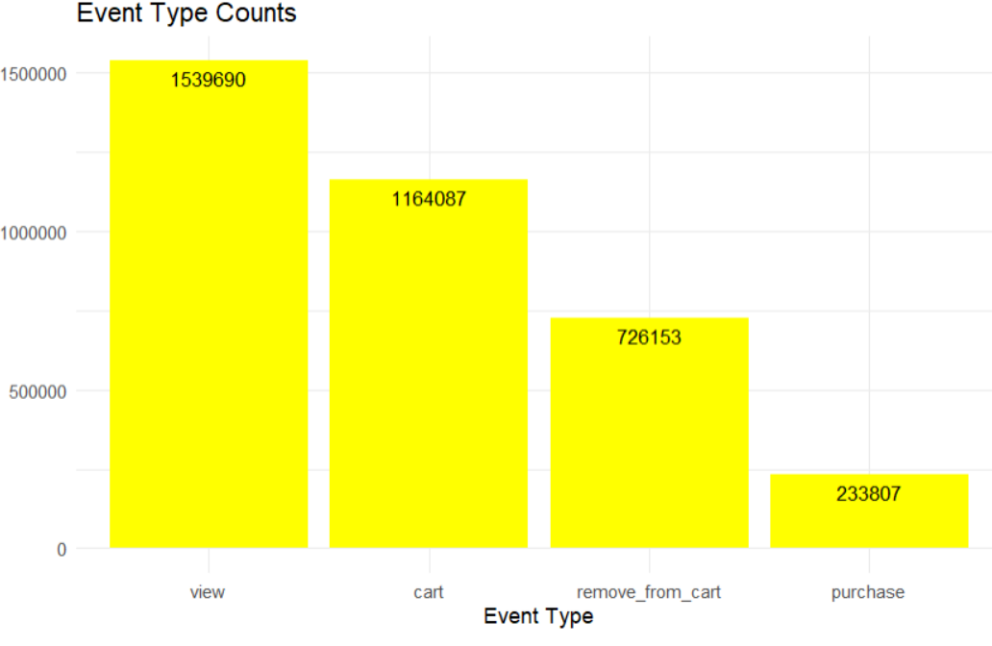
- Decile-wise Lift Chart (28 and 100 Percentile): The chart provides information about the performance of the decision tree model across different Decile such as a lift at 28% shows that model is at least 28% more effective then randomly guessing either the customer will add the product in their chart or not.
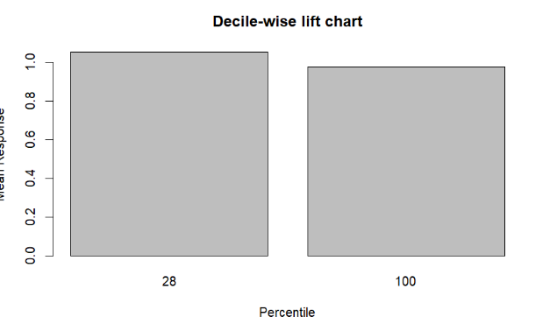
- Decile-wise Lift Chart (53 and 100 Percentile): Similar to decision tree decile chart this is the chart that provides information about the performance of the logistic regression model across different Decile such as a lift at 53% shows that model have a really positive power of predicting less false positive and can effectively have better chance of telling either the product will be added to the customer chart or not.
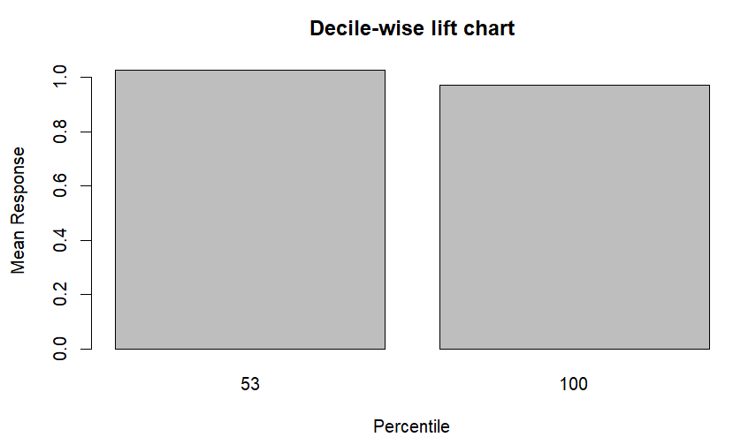
- Logistic Regression Lift vs. Percent Tested: Lift chart shows overall predictive capability of the model on the dataset. The model achieved the lift of 106 at its top decile shows that logistic model is quiet effective in predicting the product that can be added into the chart.
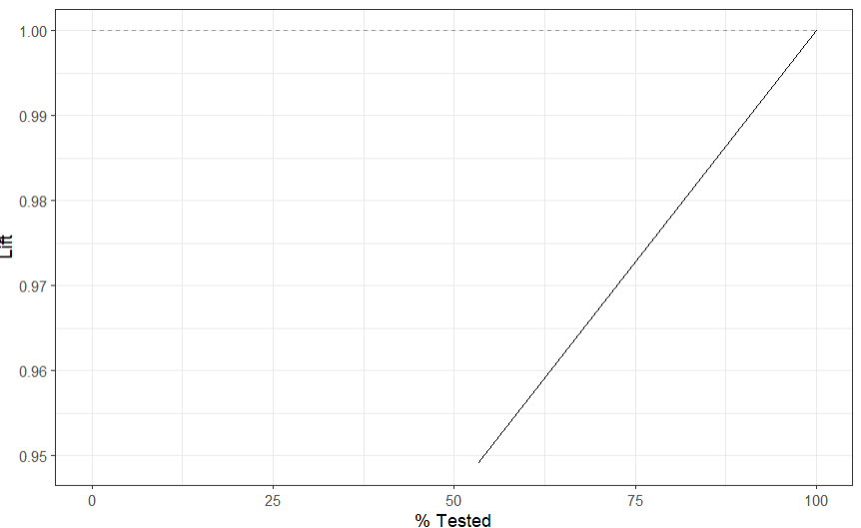
- Decision Tree Lift vs. Percent Tested: This Lift chart shows overall predictive capability of the decision tree model on the dataset. The model achieved the lift of 110 at its top decile shows that it performed even better then logistic regression model in overall predicting either the product will be added in the chart or not.

